ACKNOWLEDGEMENT

We owe a great many thanks to a great many people who helped and supported us during this project. Our deepest thanks to **Dr. BIMAL DATTA and** **Mr PALASH DUTTA** for guiding and suggesting various documents with attention and care. They have taken responsibility to go through the details and make necessary correction as and when needed. We express our thanks to the **HOD, Dr (Prof) BIMAL DATTA** of Computer Science & Engineering for extending his support. Our deep sense of gratitude to our classmates for helping us with this project. We also extend our heartfelt thanks to our family members to encourage us to complete this project.

RUDRANIL SARKAR 27600113039

SOUNDARYA DHALI 27600113051

MONOSWINI GHOSH 27600113025

# CERTIFICATE

This is to certify that the project topic entitled **EMOTION DETECTION USING EDGE DETECTION and MORPHOLOGICAL OPERATIONS** has been developed by **RUDRANIL SARKAR (**Roll-27600113039)**, SOUNDARYA DHALI (**Roll-27600113051), **MONOSWINI GHOSH** **(**Roll-27600113025) andStudents of 4TH Year **Computer Science Engineering** Department of **Budge Budge Institute of Technology**. They worked on the topic **EMOTION DETECTION USING EDGE DETECTION and MORPHOLOGICAL OPERATIONS**. Their work is satisfactory.

I wish them all success in their life.

**Dated: -**

**HOD Mr. Palash Dutta**

**Dr. Bimal Datta**

DECLARATION

I hereby declare that the project work entitled

**Human Emotion Detection using MATLAB** submitted

to the Maulana abul kalam azad University of technology, is a record of an original work done by us under the guidance of

**Dr. Bimal Datta and Mr. Palash Dutta**

Of Budge Budge Institute of Technology department of Computer Science & Engineering and this project work has not performed the basis for the award of any Degree or diploma/ associateship/fellowship and similar project if any.

RUDRANIL SARKAR 27600113039

SOUNDARYA DHALI 27600113051

MONOSWINI GHOSH 27600113025

PROJECT OBJECTIVE.

We know that emotions play a major role in a Human life. At different kind of moments or time Human face reflects that how he/she feels or in which mood he/she is. Humans are capable of producing thousands of facial actions during communication that vary in complexity, intensity, and meaning. Emotion or intention is often communicated by subtle changes in one or several discrete features. We will use this system which will be able to capture human emotions by reading or comparing facial expressions. Algorithm automatically extracts features and their motion information, discriminate subtly different facial expressions, and estimate expression intensity. In this project we are going to develop a system which is capable for achieving human emotion. Our system depends upon human face as we know face also reflects the human brain activities or emotions. In this project we will also try to use neural network for better results by using an existing system.

Therefore, our project objective is to develop a hybrid system which will detect the human emotion like happy, sad, disgust, angry, surprise, fear using edge detection technique with respect to neutral image.

METHODOLOGY

This system describes the facial emotion detection using edge detection and morphological operation based on eye, mouth and eyebrow. Each of the input image have some features like face, mouth eye and eyebrow, our system will detect such kind of facial features mention above. Now firstly system will detect the face using Viola-Jones algorithm then it will detect the facial features like eye, mouth and eyebrow then we will crop that portion from the original input image.Now morphological operation is perform on extracted facial features (face, mouth, eye and eyebrow) morphological operation like open, erosion, dilution and close are perform on facial features then noise removal technique is used to remove the unwanted noise from the facial features, now edge detection is perform on that image using edge detection it will detect the image boundary of the facial features there are many types of edge detection like sobel, canny and prewitt etc are used to detect the edge of an image in our system we used all the types to get the best result. Now using boundary value algorithm we crop the exact boundary of an facial features then we calculate the box ratio of all the facial features which help to determine emotion of an image. All the emotion are detect with respect to the neutral image, there are six universal emotions these are happiness, sadness, anger, surprise, disgust and fear our system will detect this emotion with respect to the neutral image. Shown in figure 1.0.

Neutral Expressions

C:\Users\RUDRA\Desktop\Project\jaffe\KL.NE2.156.tiff C:\Users\RUDRA\Desktop\Project\jaffe\KL.NE2.156.tiff C:\Users\RUDRA\Desktop\Project\jaffe\KL.NE2.156.tiff C:\Users\RUDRA\Desktop\Project\jaffe\KL.NE2.156.tiff C:\Users\RUDRA\Desktop\Project\jaffe\KL.NE2.156.tiff C:\Users\RUDRA\Desktop\Project\jaffe\KL.NE2.156.tiff

C:\Users\RUDRA\Desktop\Project\jaffe\KL.SA3.163.tiff C:\Users\RUDRA\Desktop\Project\jaffe\KL.SU1.164.tiff C:\Users\RUDRA\Desktop\Project\jaffe\KL.HA1.158.tiff C:\Users\RUDRA\Desktop\Project\jaffe\KL.DI4.173.tiff C:\Users\RUDRA\Desktop\Project\jaffe\KL.FE2.175.tiff C:\Users\RUDRA\Desktop\Project\jaffe\KL.AN1.167.tiff

1. Sad (b) Surprise (c) Happy (d) Disgust (e) Fear (f) Angry

For conducting execution of the work JAFFE database is used.

Figure 1.0

**WORK DESCRIPTION**

* **FACE REGION**

Using this system our objective is to develop a hybrid model for detection of the human emotion to do that our first work is to detect the human face using Viola-Jones Algorithm this algorithm has four stages are follows.

1. Haar Feature Selection
2. Creating an Integral Image
3. Adaboost Training
4. Cascading Classifiers

Using this different stages Viola-Jones Algorithm differentiate face and non-face image. Firstly we take a gray-scale image as an input then we apply Viola-Jones Algorithm it will detect the human face after detection we cropped the face portion from the original image and take that portion into an array. The detection shown in the figure 1.1

Figure 1.1

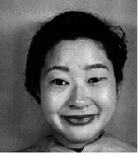 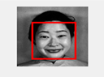 

**Original image Detected image Crop image**

* **LIP REGION**

Now lip area is detected using Viola-Jones cascading object detector after detection lip portion is extracted from the detected face after that lip portion is converted into a binary image format then morphological operation is applied on extracted lip portion like hole filling operation, open, dilution, erosion and close are morphological operation performs on lip portion, lip area may or may not contain noise to remove noise we used noise removal technique to remove the noise from the lip portion after removing the noise now we used edge detection it will detect the edge of the lip portion here in this system we use three edge detection technique sobel, canny and prewitt but for lip portion we use sobel edge detector.

After edge detection we applied boundary value algorithm on binary image it will trace the all the boundary value of lip region shown in figure 1.2 then using that boundary value we determine the ratio of the lip region these ratio are responsible for the detection of the different kind of human emotion.

**(Lip area ratio= width of the lip portion /height of the lip portion)**

Figure 1.2

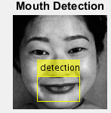     

** **

* **EYE PAIR REGION**

After lip portion now eye pair also detected in same manner using Viola-Jones cascading object detector algorithm, then eye region is extracted from the face region then extracted eye region firstly converted into a binary image format then morphological operation is performed on the binary image like hole filling operation, open, dilution, erosion and close are morphological operation applied on eye portion after that we applied noise removal technique to remove the noise from the eye region. After that sobel edge detection is perform on eye region to get the exact edge of the eye region then we divide eye region into two part left eye and right eye region (shown in figure 1.3) after that we applied boundary value algorithm to determine the boundary value of both pair of eye now using that boundary value we will calculate the ratio of the eye pair region. Using that ratio we will determine the emotion based on eye pair.

**(Eye portion ratio= width of the eye portion/height of the eye portion)**

Figure 1.3

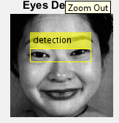   

**     **

* **EYE BROW REGION**

After eye region now we will extract the eye brow region, here for eye brow region we use a loop to extract it from the detected face after that eye brow portion is converted into a binary image format then morphological operation is applied on extracted eye brow portion like hole filling operation, open, dilution, erosion and close are morphological operation performs on eye brow portion, eye brow area may or may not contain noise to remove noise we used noise removal technique to remove the noise from the eye brow portion after removing the noise now we used edge detection it will detect the edge of the eye brow portion using sobel edge detector it will detect the edge.

After edge detection we divide the eye brow into two part left eye brow region and right eye brow region then we applied boundary value algorithm on binary image it will trace the all the boundary value of both the eye brow region shown in figure 1.4 then using that boundary value we determine the ratio of the eye brow region these ratio are responsible for the determination of the different kind of human emotion.

**(Eyebrow portion ratio= width of the eyebrow portion /height of the eyebrow portion)**

Figure 1.4

**   **

**  **

* **DETECTION OF EMOTION**

After extract all the face features we calculate all the ratio of the facial expression then we perform AND operation on facial features using different set of range of ratio of facial features system will determine emotion with the help of range of ratio.

**BLOCK DIAGRAM**

INPUT IMAGE

DETECTION OF FACE

FACE REGION CROPPING

DETECTION OF EYE PAIR

DETECTION OF LIP

EYEBROW REGION CROPPING THEN CONVERTED INTO BINARY FORMAT

EYE REGION CROPPING

LIP REGION CROPPING

MORPHOLOGICAL OPERATIONS, NOISE REMOVAL AND EDGE DETECTION APPLIED

IMAGE INTENSITY VALUE ADJUSTED AND CONVERTED INTO BINARY FORMAT

CONVERTED TO BINARY FORMAT

MORPHOLOGICAL OPERATIONS, NOISE REMOVAL AND EDGE DETECTION APPLIED

MORPHOLOGICAL OPERATIONS, NOISE REMOVAL AND EDGE DETECTION APPLIED

BOUNDARY OF THE IMAGE IS OBTAINED AND EYE BROW REGION DIVIDED INTO TWO PART

BOUNDARY OF THE IMAGE IS OBTAINED AND DIVIDED EYE INTO TWO PART

BOUNDARY OF THE IMAGE IS OBTAINED AND BOX RATIO OF LIP IS CALCULATED

BOX RATIO OF EYE BROW IS CALCULATED

ECCENTRICITY OF EYES IS FOUND OUT

EMOTION IS DETECTED

**IMPLEMENTATION**

Algorithm

* Detection of human face

1. Input a gray scale image

2. Resize the image

3. Face Detection is performed using Viola Jones Cascading Object Detector

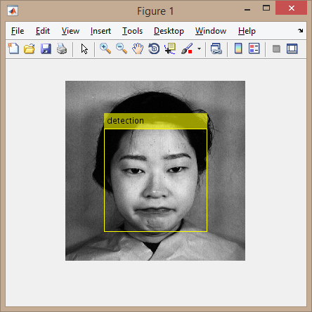

4. Extract the detected part from the orginal image and store in a variable

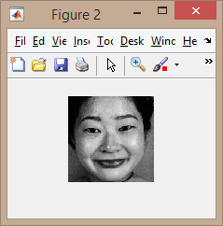

LIPS DETECTION

5. The lip area is detected with respect to a threshold value.

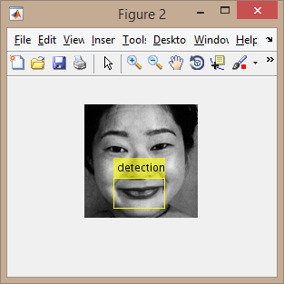 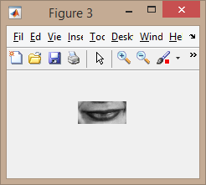

6. The detected lip area is then converted into binary image format.

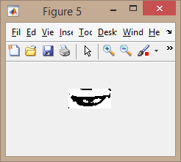

7. Morphological operations are performed on the binary image

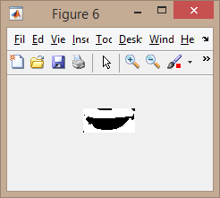

8. Noise removal technique is then applied to the binary image, to remove any noise present in the image.

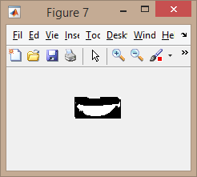

9. Edge detection technique is applied and the boundary region of the image is obtained

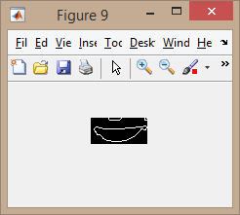

10. The ratio of the width and height of the lip region is calculated.

EYE PAIR DETECTION

11. The Eye Detection is performed on the face image which was extracted from the input image

12. The eye region is detected.

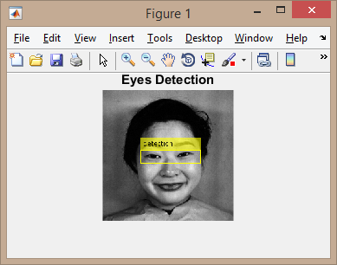

13. The image intensity value is then adjusted.

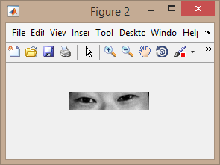

14. The detected eye area is then converted into binary image format.

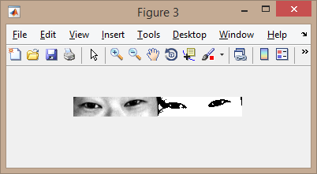

15. Morphological operations are performed on the binary image.

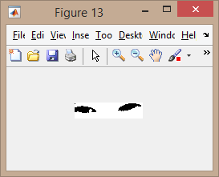

16. Noise removal technique is applied.

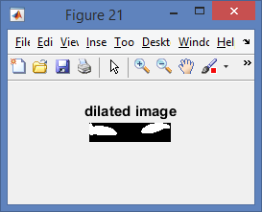 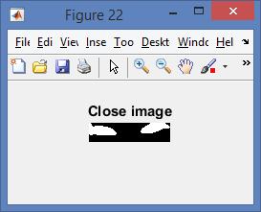

17. Edge detection technique is applied and the boundary region of the image is obtained.



18. The eye region is divided into two parts-left and right.

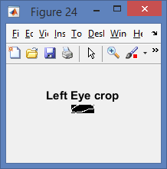 

19. The eccentricity of the eyes is to be found out.

20. Based on the eccentricity of the eyes and the obtained box ratio of the lips, image detection is performed.

EYE BROW CROPPING

21. The eye brow region is cropped from the face detected image using loop

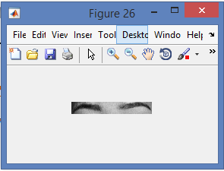

22. The cropped eye brow region area is then converted into a binary image format.

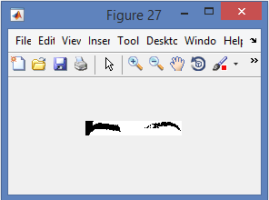

23. The morphological operation and noise removal technique is performed on the binary image.

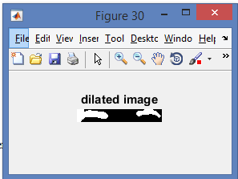 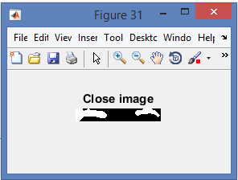

24. The edge detection technique is applied and the boundary region of the image is obtained.

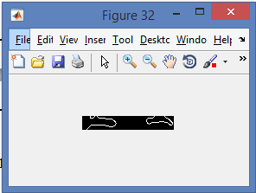

25. The eye brow region is divided into two parts, left and right eye.

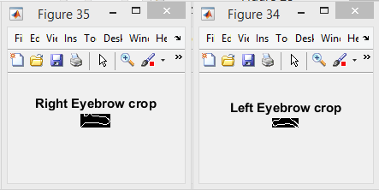

26. The ratio of the width and height of the eye brow region is calculated.

27. Based on the ratio of eye brow and mouth, and eccentricity of the eyes it will detect the human emotion.

**ALGORITHM FOR FINDING BOUNDARY VALUE**

Step-1 Initialize

count<-0

xmax<-0,xmin<-0

ymax<-0,ymin<-0

Step-2 Store the size of the image in two dimension array which consist of row denoted by m and column denoted by n

Step-3

for i<-1 to m

for j<-1 to n

if (i,j)>0

if count = 0

xmin<-i;

ymin<-j;

ymax<-j;

count<-count+1;

else

xmax<-i;

if ymin>j

ymin<-j;

end

if ymax<j

ymax<-j;

end

end

end

end

end

Step-4 Ithresh<-(xmin:xmax,ymin:ymax)

Step-5 return Ithresh

RESULT AND DISCUSSION

**Different ranges of ratio for happy faces**

|  |  |  |
| --- | --- | --- |
| FACIAL FEATURE | Minimum ratio | Maximum ratio |
| Mouth | 1.9310 | 3.3750 |
| Left eye | 1.7778 | 2.7273 |
| Right eye | 1.6667 | 2.4545 |
| Left eye brow | 2.0000 | 3.8889 |
| Right eye brow | 1.2105 | 2.1875 |
|  |  |  |

**Different ranges of ratio for sad faces**

|  |  |  |
| --- | --- | --- |
| FACIAL FEATURE | Minimum ratio | Maximum ratio |
| Mouth | 1.2320 | 3.1720 |
| Left eye | 1.2711 | 2.3572 |
| Right eye | 1.7677 | 2.2450 |
| Left eye brow | 2.2100 | 3.8000 |
| Right eye brow | 1.3205 | 3.1876 |
|  |  |  |

**Different ranges of ratio for fear faces**

|  |  |  |
| --- | --- | --- |
| FACIAL FEATURE | Minimum ratio | Maximum ratio |
| Mouth | 1.8310 | 2.1750 |
| Left eye | 1.8771 | 3.1173 |
| Right eye | 1.7677 | 3.2545 |
| Left eye brow | 2.2002 | 3.1881 |
| Right eye brow | 1.0105 | 2.2875 |
|  |  |  |

Till now so far we able to take the ratio of all the facial features like mouth, left eye, right eye, left eye brow and right eye brow to detect only happy face. If any input image facial features come under above calculated range the system will detect that the input image is Happy otherwise it will not detect and throw some error message to the user.

Like happy we have to calculate the range for sad,disgust,surprise,fear,angry with respect to neutral image.

SAMPLE OUTPUT

Face Detected

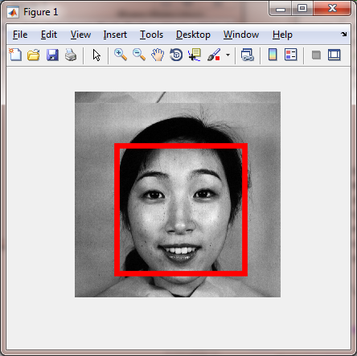

Mouth Detected

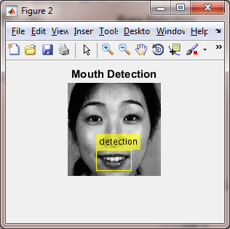

Eye pair Detected

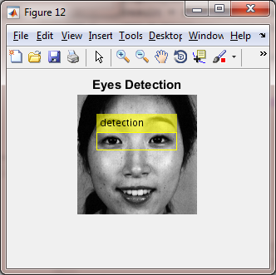

Emotion Detected

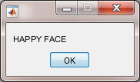

CONCLUSION

We studied emotion recognition process by using various techniques. This system gives an overview of the few techniques available for emotion detection and recognition. It will help to understand these techniques in short and to choose from them which can be well suited for future evaluation depending on the individual.

Though there are various techniques available but the key concept remains the same. We have to first select that portion of the images which helps in detecting the emotions. These feature extraction method is performed using various techniques such as 3-D model techniques, Matlab, patch based feature extraction. We are used matlab for features extraction and after extracting the features the ratio should calculated which determine emotion.The output of the system is emotion of the input image.

FUTURE WORKS OF THIS SYSTEM

* Threshold value are given manually in this system but we can develop such a system that threshold value itself generated by the system.
* We can apply neural networks, deep belief network method.
* We can use bezier curve algorithm to detect eye brow, mouth etc.

REFERENCES

[1] P. Dutta and D. Bhattacharjee, “Face Detection Using Generic Eye

Template Matching”, 2nd International Conference on Business &

Information Management (ICBIM-2014), 09 - 11 January 2014, NIT

Durgapur, India, vol. 2 ISBN- no. 978-1-4799-3263-4 @IEEE, p-36-40.

[2] U.A. Khan, M.I. Cheema and N.M. Sheikh, “Adaptive video encoding based on skin tone region detection”, in Proceedings of IEEE Students

Conference, Pakistan, 16-17 August 2002, vol (1), pp. 129-34.

[3] J. B. Li, J. S. Pan, and Z. M. Lu, “Kernel optimization-based

discriminate analysis for face recognition”, Neural Computing and

Applications, vol. 18, no. 6, pp. 603-612, 2009.

[4] J. B. Li, J. S. Pan and Z. M. Lu, “Face recognition using

Gabor-based complete kernel Fisher discriminate analysis with

fractional power polynomial models”, *Neural Computing and*

*Applications*, vol. 18, no. 6, pp. 613-621, 2009.

[5] S. Krinidis, and I. Pitas, “Statistical analysis of human facial

expressions”, *Journal of Information Hiding and Multimedia Signal*

*Processing*, vol1, no3, pp. 241-260, 2010.

[6] D.Bhattacharjee, M.Nasipuri, D.K.Basu, M.Kundu, S.Halder, “Face

Synthesis (FASY)System for Generation of a Face Image from Human

Description”, 2008 IEEE Region 10colloquium and the Third

International Conference on Industrial and Information Systems,

Kharagpur, INDIA December 8-10, 2008.